# **AWS Cloud computing ZERO to HERO**

# **Assignment 2 | 29th August 2021**

## Question 1

Assignment 1

Working with IAM users

1.Create a user

2.Attach a policy to the user

3.Login as IAM user and show permissions in action

Assignment 2

Working with EC2 compute

1.Create an ec2 instance

2.Connect to an instance and run a system update

3.Enable termination protection and check how it works

4.Disable termination protection and terminate the instance

Assignment 3

Working with VPC

1.Create a VPC

2.Create a internet gateway and attach to VPC

3.Create a route table and add route to igw

4.Make the custom route table the main route table

5.Create the subnet

6.Modify auto assign IP settings for the subnet.

7.Launch a ec2 instance in custom vpc

Assignment 4

Deploying an application on Elastic beanstalk

1.Create an elastic beanstalk application

2.Create web server environment

3.Deploying a sample application

Assignment 1

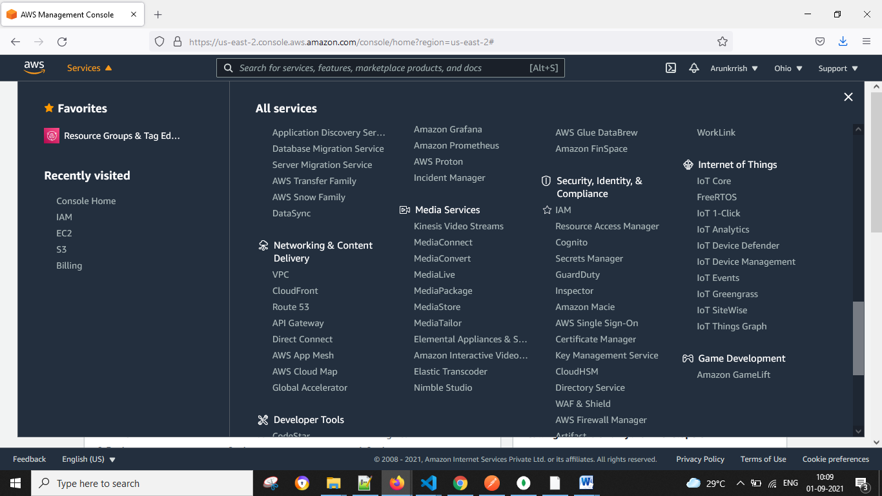

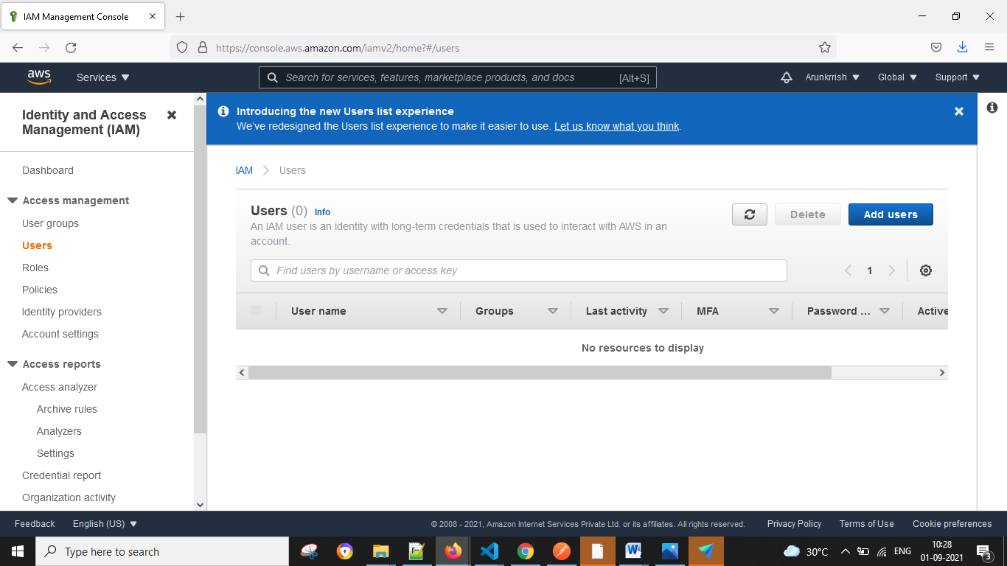

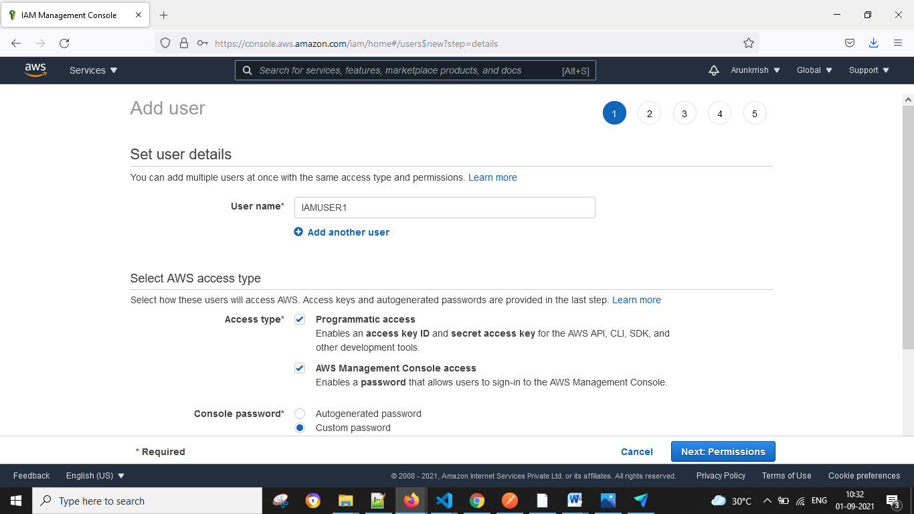

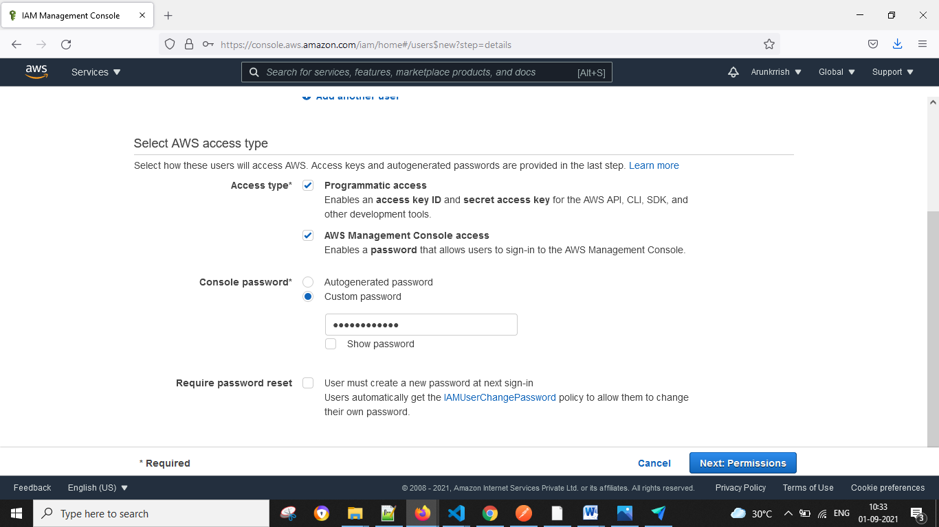

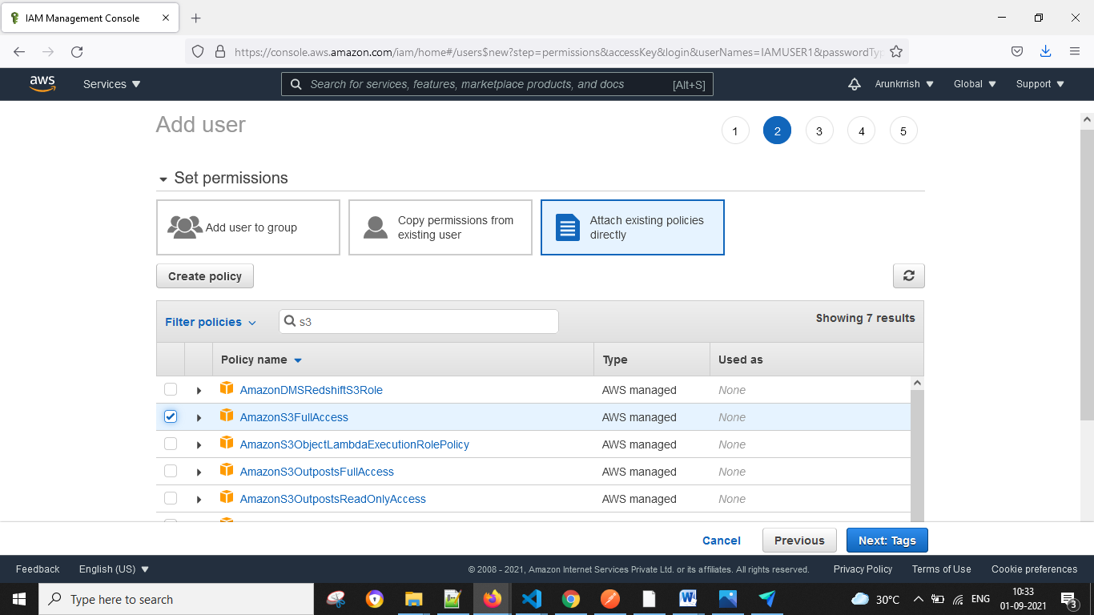

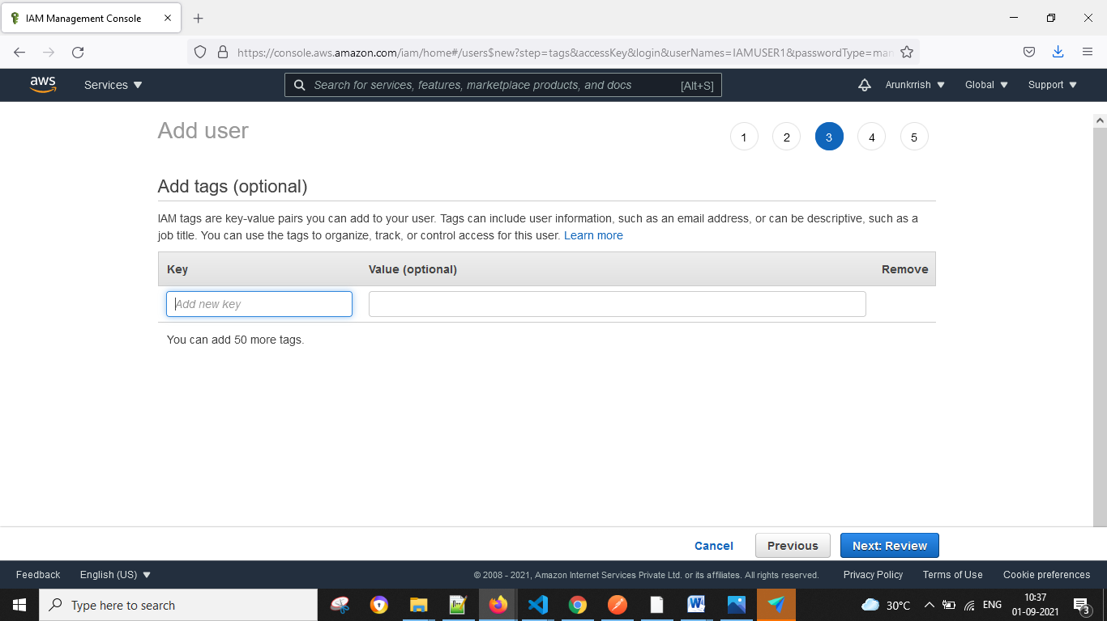

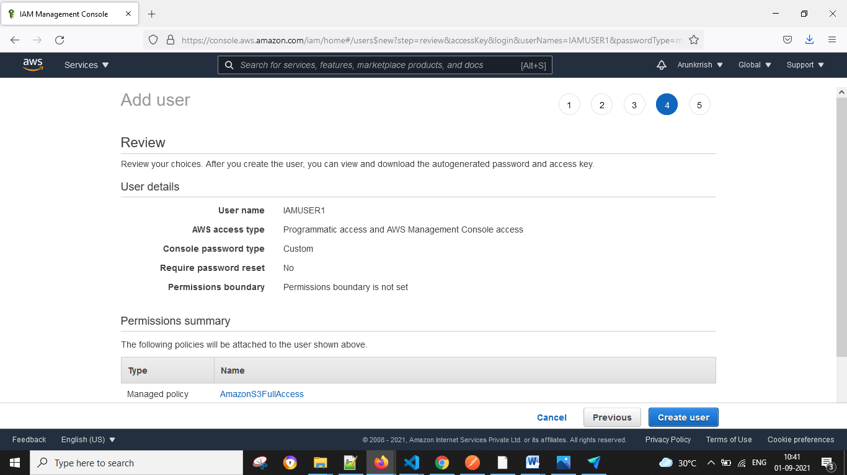

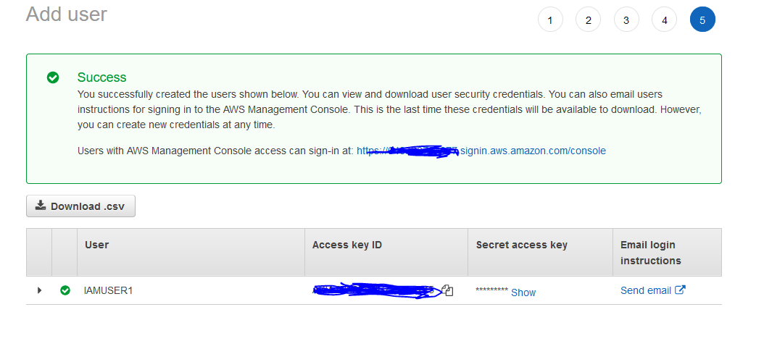

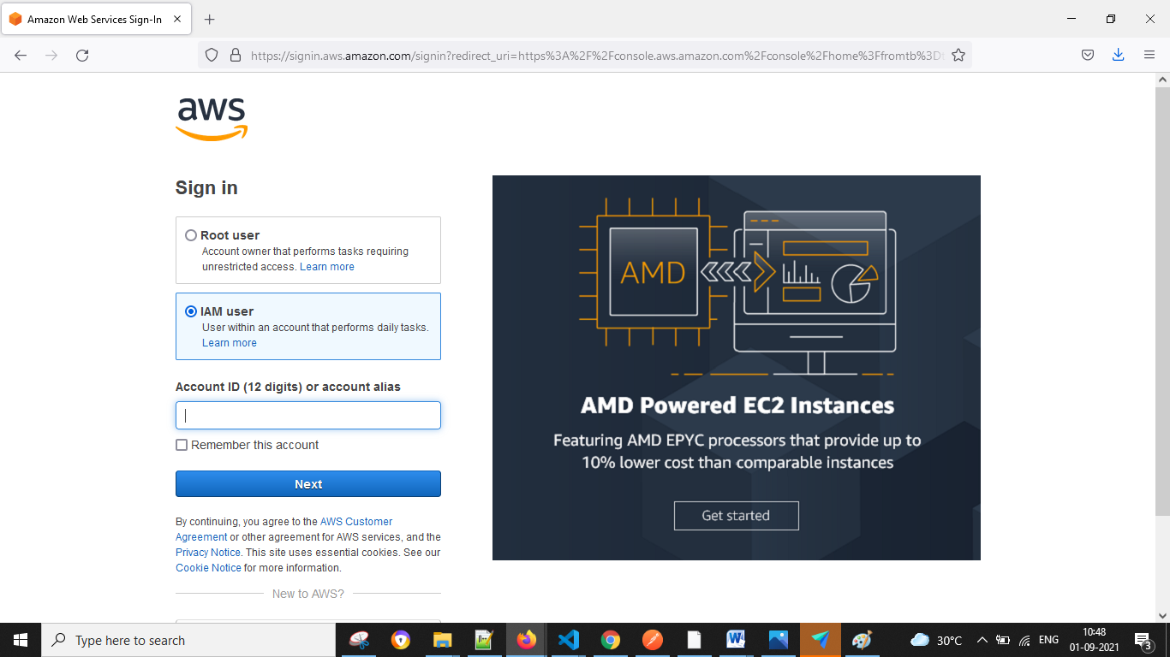

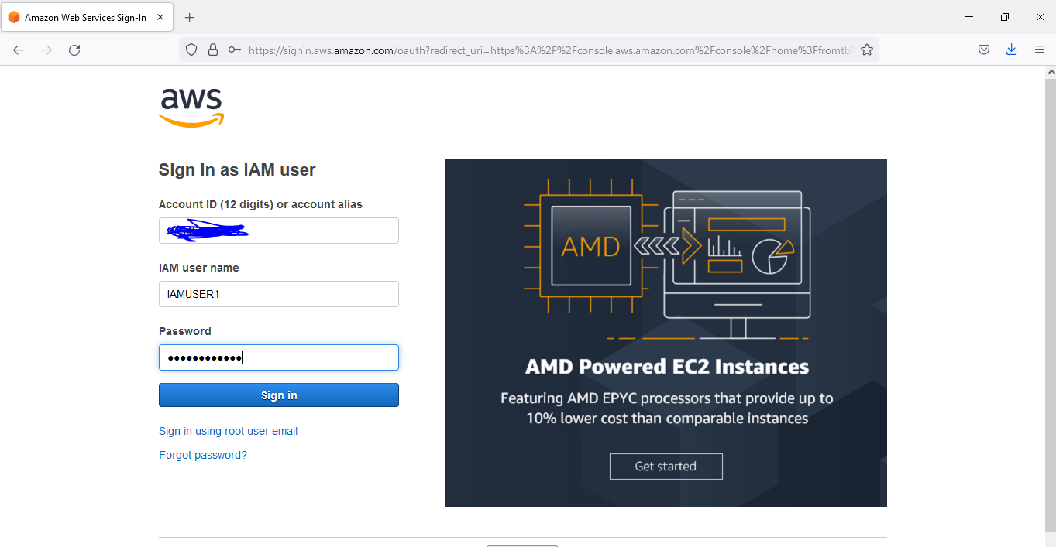

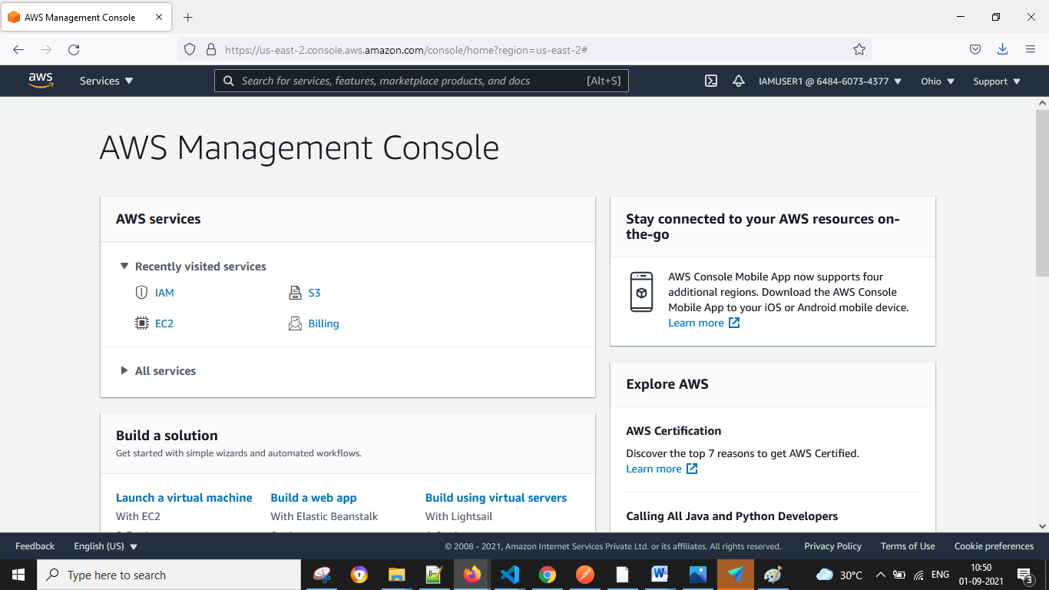

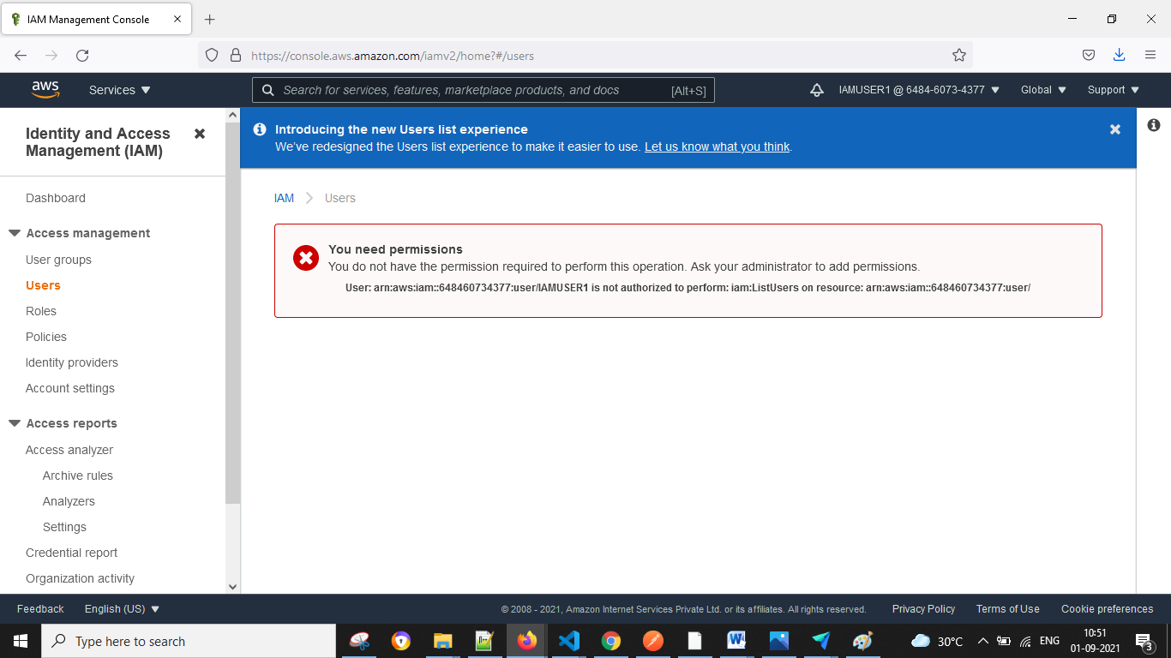

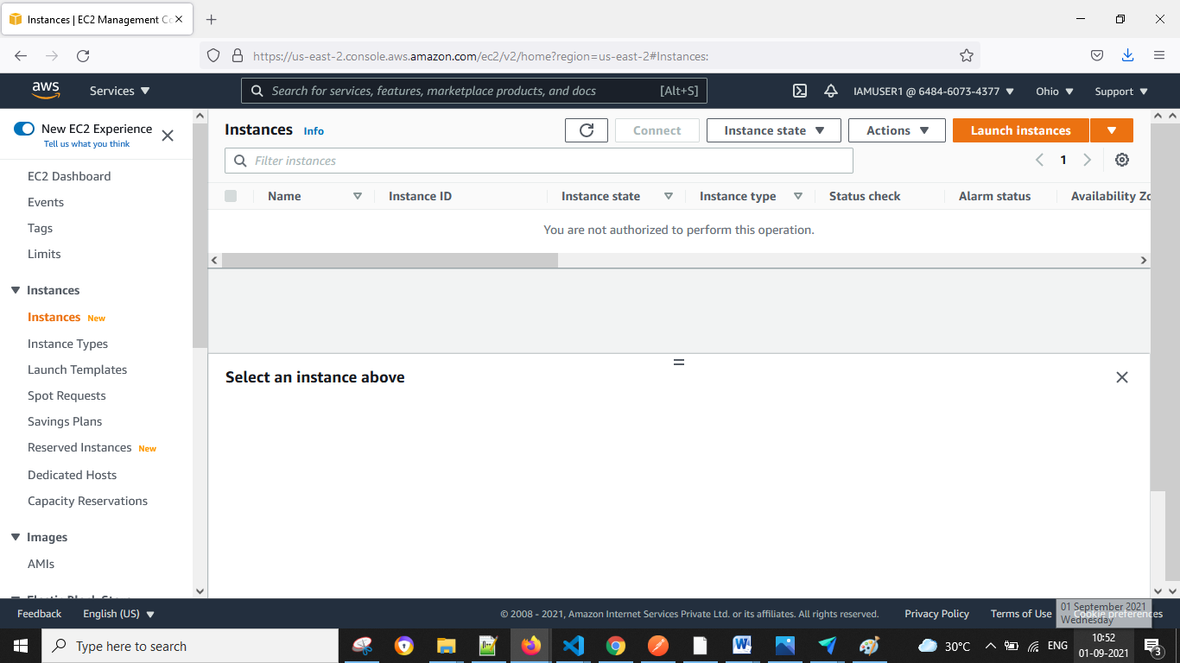

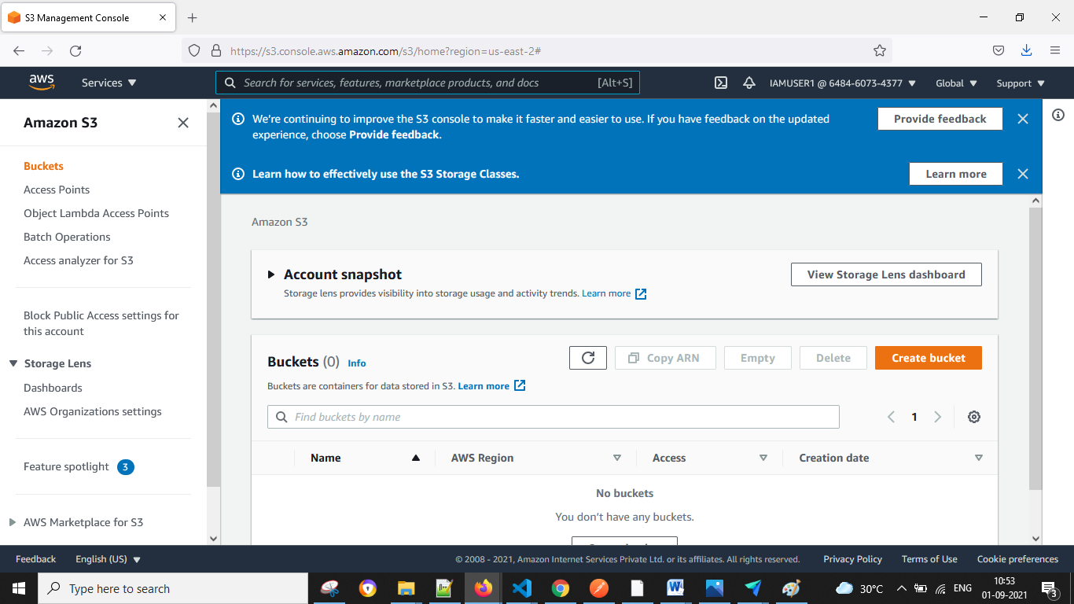

Assignment 2

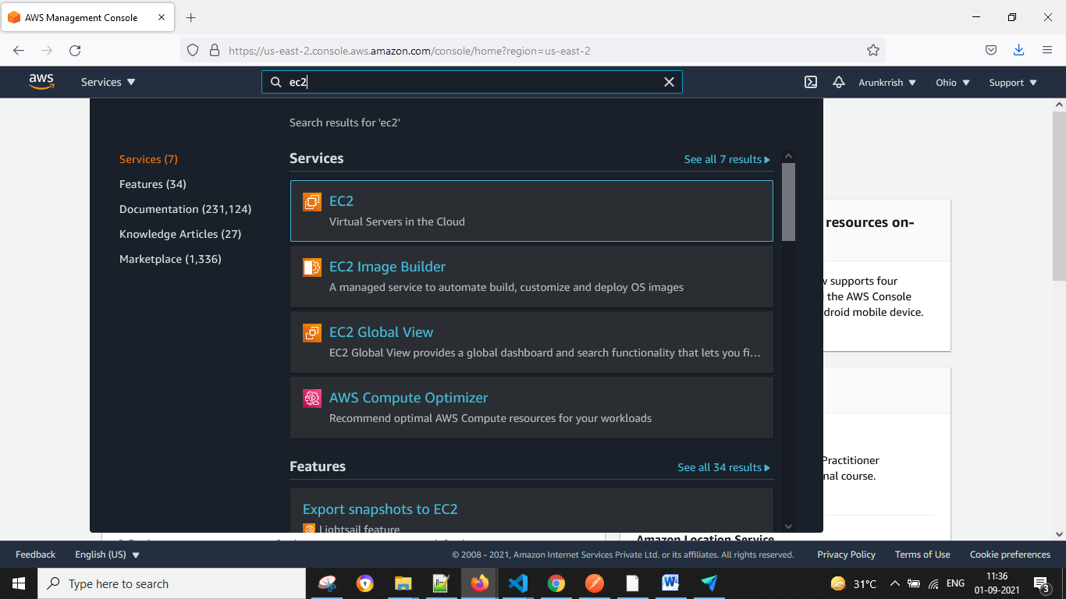

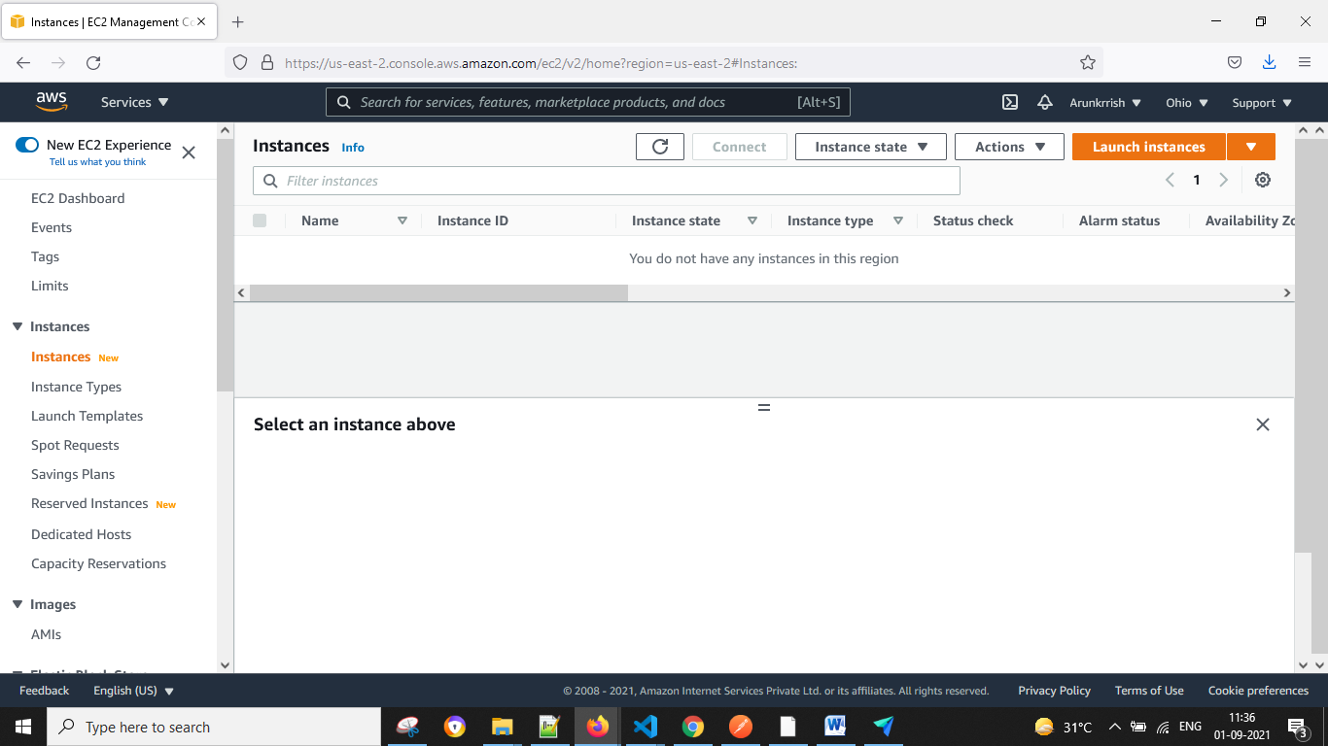

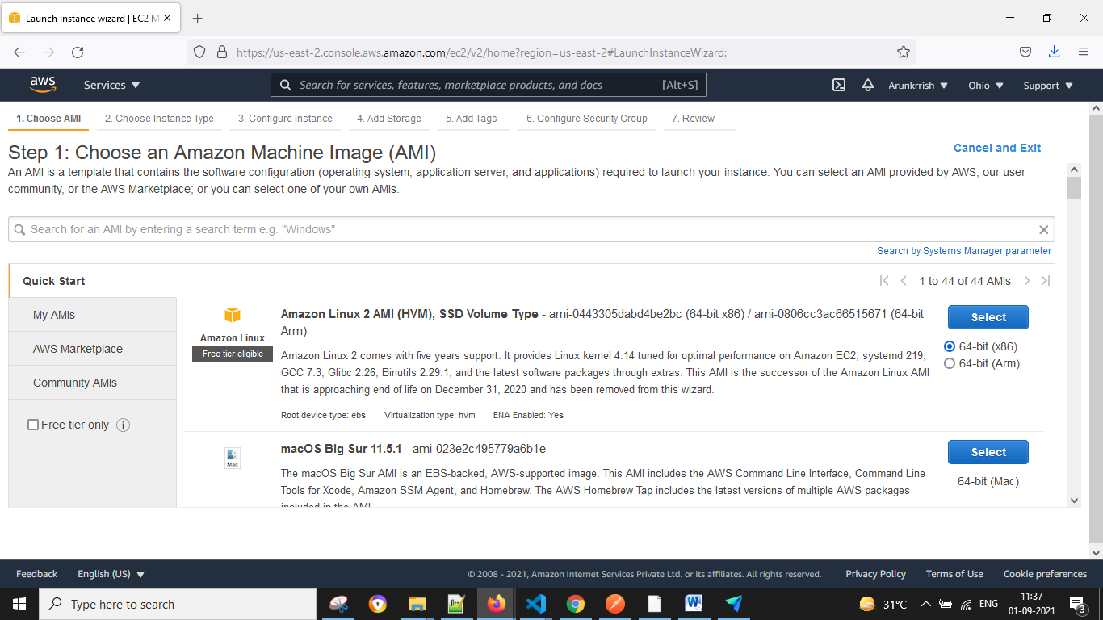

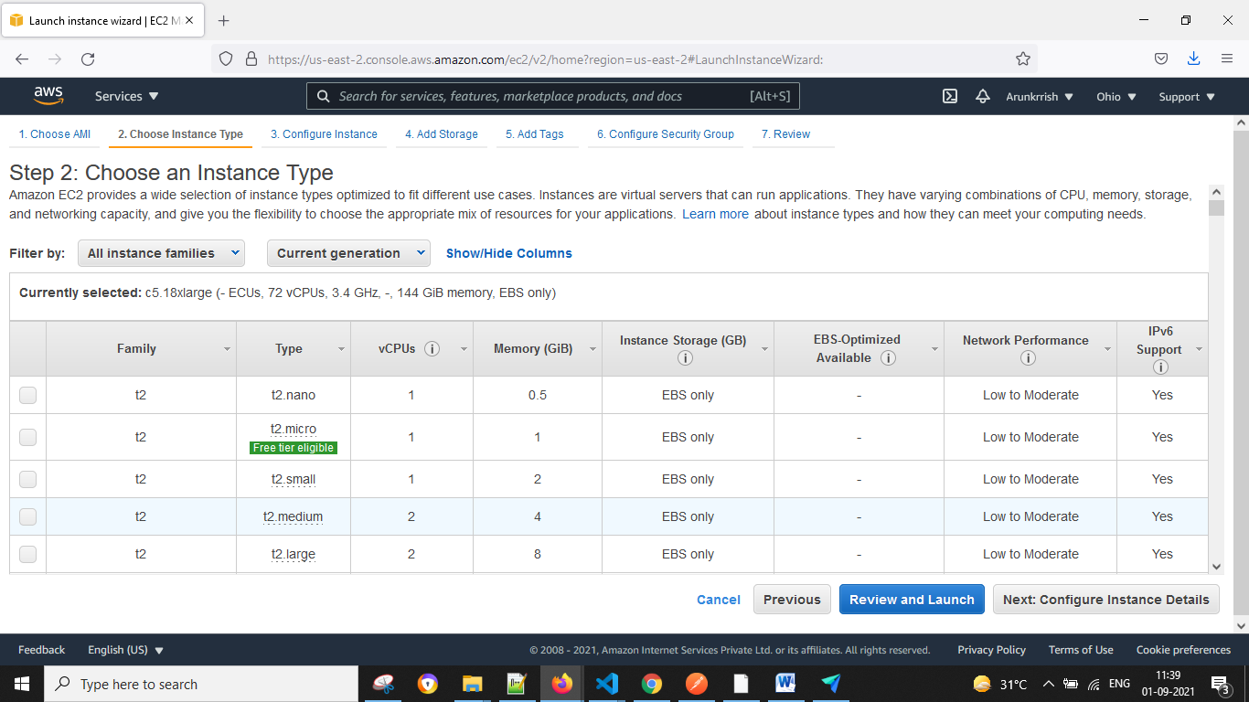

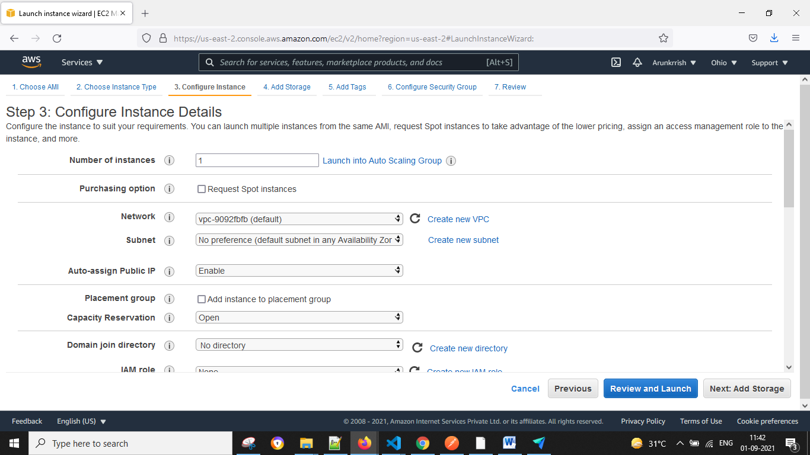

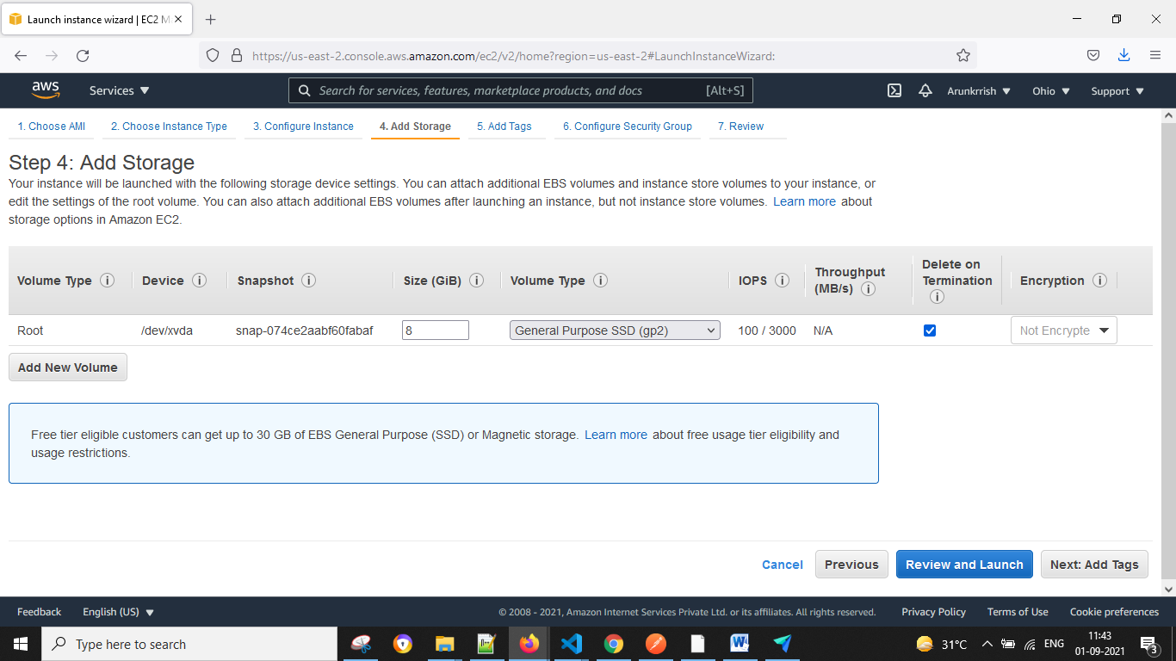

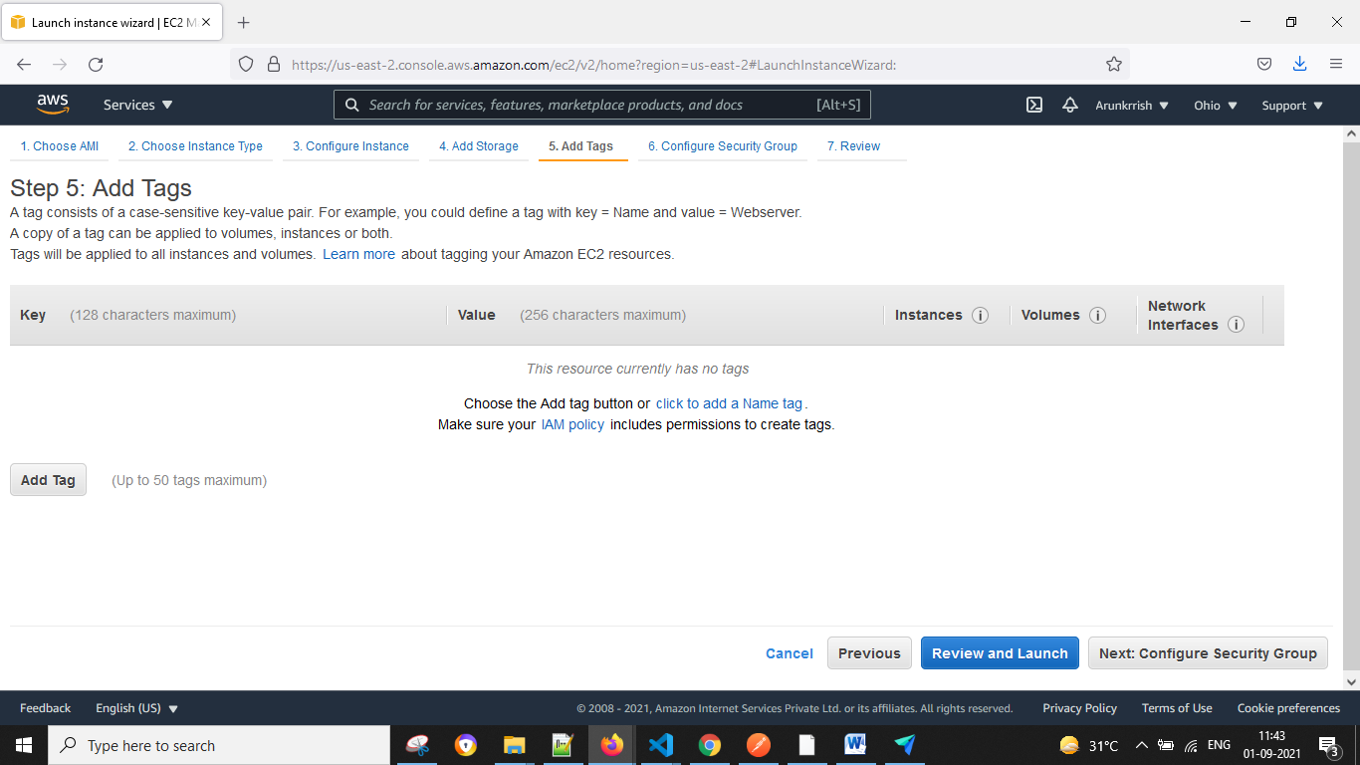

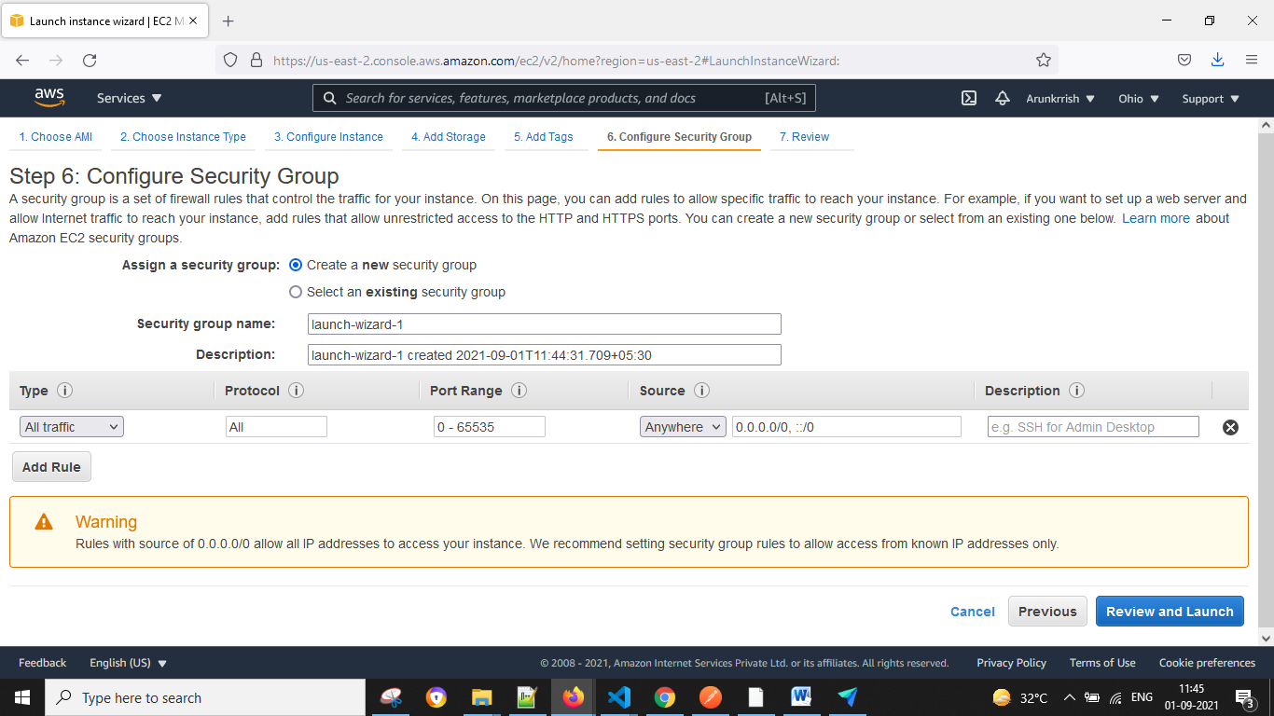

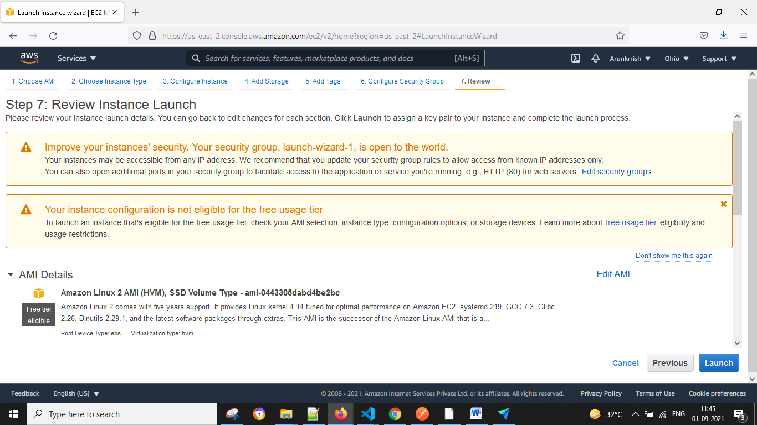

Assignment 3

Assignment 4